# Lab 2.1 Enhance the Fahrenheit to Celsius application

In this exercise, you’ll add data validation to the application you created in Lab1.

You’ll also let the user do multiple conversions before ending the application. This is the dialog box for an invalid entry:

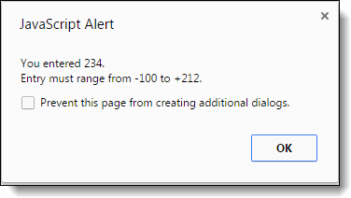

1. If you didn’t already do the exercise in Lab1, do it now.
2. Add data validation to the application so it won’t do the conversion until the user enters a Fahrenheit temperature between -100 and 212. If the entry is invalid, a dialog box like the one above should be displayed.
3. Add a loop to the code so the user can do a series of calculations without restarting the application. To end the application, the user must enter 999 as the temperature.
4. Test the application.